1)Python Program to Print Hello world!
print("hello world!")
OUTPUT:
2)Python Program to Add Two Numbers
a=int(input("enter first number:"))
b=int(input("enter second number:"))
print("addition is :",a+b)
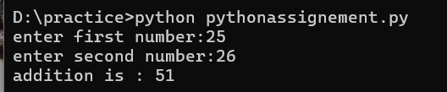
3)Python Program to Find the Square Root
a=int(input("enter number:"))
print("square of the given number is :",a*a)

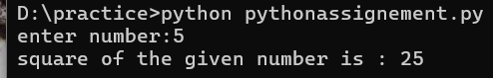
4)Python Program to Calculate the Area of a Triangle
print("Area of triangle:")
height=float(input("enter height :"))
base=float(input("enter base:"))
Area=1/2*(base*height)
print("area of triagle:",Area )

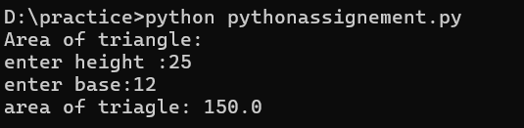
5)Python Program to Swap Two Variables
a=int(input("enter first number:"))
b=int(input("enter second number:"))
print("before swap value of a and b",a,b)
temp=b
b=a
a=temp
print("After swap value of a and b",a,b)

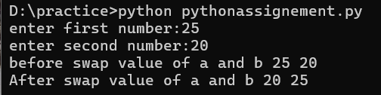
6)Python Program to Generate a Random Number
from random import *
for x in range(5):
print("random number:",randint(0,100))

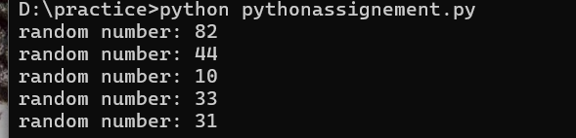
7)Python Program to Check if a Number is Positive, Negative or 0
num=int(input("enter the number:"))
if num>0:
print("number is positive")
elif num<0:
print("number is negative")
else:
print("number is zero")
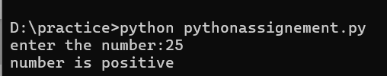
8)Python Program to Convert Kilometers to Miles
a=int(input("enter kilometer to convert in miles:"))
miles=a*0.621371
print("coverted to miles:",miles)
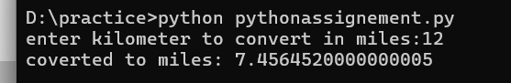
9)Python Program to Check if a Number is Odd or Even
num=int(input("enter any number:"))
if num%2==0:
print("num is even")
else:
print("num is odd")
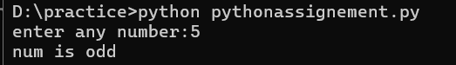
10)Python Program to Display the multiplication Table
i=1
for x in range(1,11):
print("2 *",i,"=",2*x)
i+=1
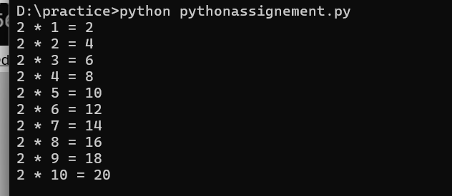
11)Python Program to Check Leap Year
year=int(input("enter any year:"))
if((year%4==0 and year%100!=0)or (year%400==0)):
print("year is leap year")
else:
print("year is not a leap year")
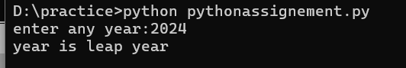
12)Python Program to Convert Celsius To Fahrenheit
a=int(input("Celsius value to convert in fahrenheit:"))
fahrenheit=(a *9/5) + 32
print("coverted celsius to fahrenheit:",fahrenheit)
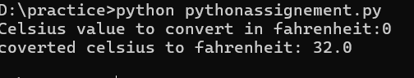
13)Python Program to Find the Largest Among Three Numbers
a=int(input("enter first num:"))
b=int(input("enter second num:"))
c=int(input("enter third num:"))
result=a if a>b and a>c else b if b>c else c
print("largest num is:",result)
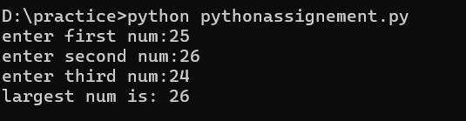
14)Python Program to Find ASCII Value of Character
a=input("enter any character:")
print(ord(a))
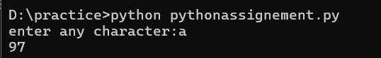

15)Python Program to Check Prime Number
num=int(input("enter any number:"))
a=0
for x in range(1,num+1):
if(num%x==0):
a=a+1
if(a==2):
print("prime num")
else:
print("num is not prime")
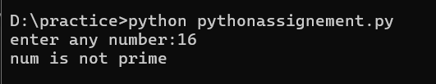
16)Python Program to Sort Words in Alphabetic Order
a=input("enter some words:")
print(sorted(a))
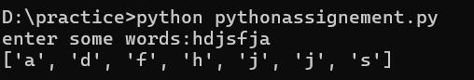
17)Python Program to Access Index of a List Using for Loop
my_list=[10,"yara",True,10.5]
for x in my_list:
print(x)
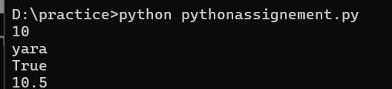
18)Python Program to Slice Lists
my_list=[10,"yara",True,10.5]
print(my_list[:])
19)Python Program to Merge Two Dictionaries
dic1={"name":"raunak","enroll":107}
dic2={"father name":"uday bhan","number":107}
dic1.update(dic2)
print(dic1)
20)Python Program to Count the Number of Each Vowel
a=input("enter some words:")
vowel=["a","e","i","o","u"]
count=0
for x in a:
if x in vowel:
count+=1
print(count)
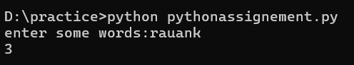
21)Python Program to Concatenate Two Lists
l1=[10,True,"yara",10.6]
l2=["rauank",12,12.06,10+6j]
print(l1+l2)

22)Python Program to Sort a Dictionary by Value
dic1={"m3":70,"ada":65,"coa":66}
l1=[]
for x in dic1.values():
l1.append(x)
print(sorted(l1))
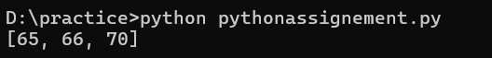
23)Python Program to Get a Substring of a String
my_string="abcdefg"
print("substring:",my_string[0:6])
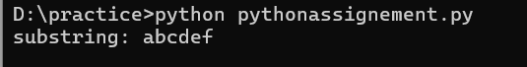
24)python Program to Reverse a Number
number=(input("enter any num:"))
print(number[::-1])
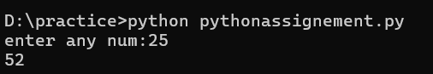
25)Python Program to Create a Countdown Timer
import time
n=int(input("enter the count down number:"))
for x in range(n):
print(x)
time.sleep(1)
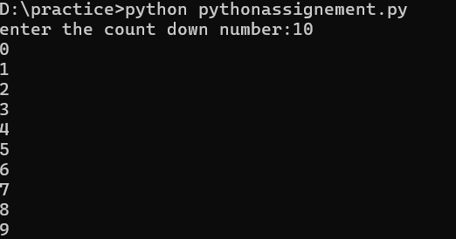
26)Python Program to Delete an Element From a Dictionary
dic1={"m3":70,"ada":65,"coa":66}
print("before",dic1)
del dic1["m3"]
print("after",dic1)
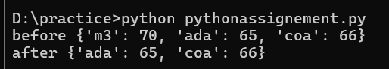
27)Python Program to Return Multiple Values From a Function
def add_multi_division(a,b):
return a+b,a*b,a/b
print(add_multi_division(10,20))
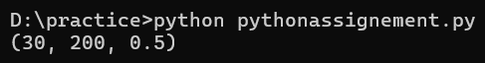
28)Python Program to Convert Two Lists Into a Dictionary
l1=[0,1,2,3]
l2=["raunak","rajsir","ramu","radha"]
dic1={}
i=0
for x in l1:
dic1[x]=l2[i]
i+=1
print(dic1)
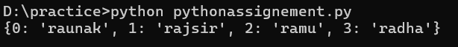
29)Python Program to Print Output Without a Newline
my_name="rauank"
my_surname="rajawat"
print(my_name,end=" ")
print(my_surname)
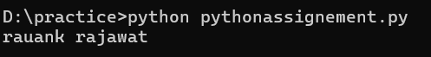
30)Python Program to Trim Whitespace From a String
my_string="raunak rajawat"
l1=my_string.split(" ")
result=""
for x in l1:
result=result+x
print(result)
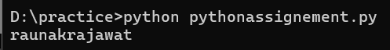
31)Python Program to Remove Duplicate Element From a List
my_list=[10,20,30,10,20]
l1=[]
for x in my_list:
if x not in l1:
l1.append(x)
print(l1)
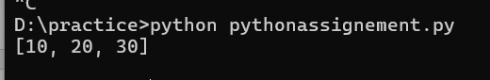
32)Python Program to Illustrate Different Set Operations
x={10,20,30,40}
y={30,40,50,60}
print(x.union(y))
print(x.intersection(y))
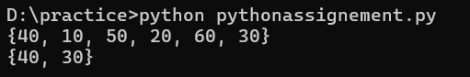
33)Python Program to Make a Simple Calculator
def calculator(a,b):
return a+b,a*b,a/b,a-b
print(calculator(50,20))
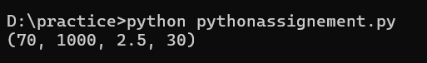
34)Python Program to Find the Factorial of a Number
num=int(input("enter any num:"))
result=1
while num>=1:
result=result*num
num=num-1
print("factorial is :",result)
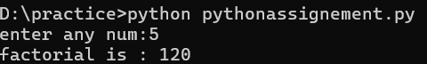
35)python Program to Create a Long Multiline String
my_intro="""my name is rauank
i am doing b.tech in CSE"""
print(my_intro)
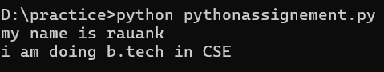
36)Python Program to Check if a Key is Already Present in a Dictionary
dic1={"m3":70,"ada":65,"coa":66}
a="coa"
if a in dic1:
print("key is already present")
else:
print("key is not present")
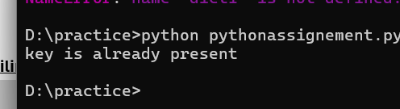
37)Python Program to Check If a List is Empty
my_list=[]
if len(my_list)==0:
print("list is empty")
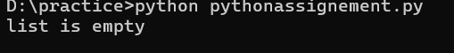
38)Python Program to Print the Fibonacci sequence
num=int(input("enter any number:"))
PN=0
CN=1
for x in range(1,num):
PPN=PN
PN=CN
CN=PPN+PN
print(CN)
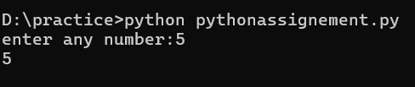
39)Python Program to Remove Punctuations From a String
punctuations = """!()-[]{};:'"<>./?@#$%^&*_~"""
my_name="hello! my name is raunak."
no_punct=""
for x in my_name:
if x not in punctuations:
no_punct=no_punct+x
print(no_punct)
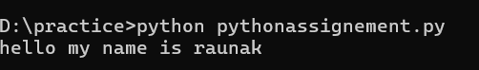
40)Python Program to Iterate Over Dictionaries Using for Loop
dic1={"m1":63,"ec":26,"cs":69}
for k,v in dic1.items():
print(k,v)
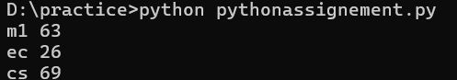
41)Python Program to Find Sum of Digits
num=int(input("enter number:"))
sum=0
while num>0:
digit=num%10
sum+=digit
num//=10
print("sum of digits:",sum
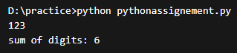
42) Python Program to Check Palindrome Number
num=input()
if num==num[::-1]:
print("palindrome")
else:
print("not palindrome")
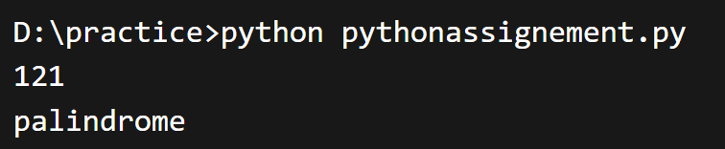
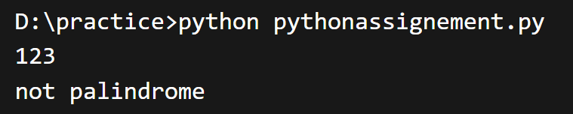
43) Python Program to Count Words in a Sentence
sentence=input()
words=sentence.split()
print("number of words:",len(words))
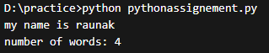
44) Python Program to Find Maximum in a List
l=[10,45,2,89,23]
print("maximum value:",max(l))
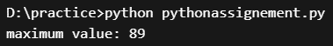
45) Python Program to Find Minimum in a List
l=[10,45,2,89,23]
print("minimum value:",min(l))
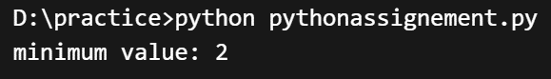
46) Python Program to Check Armstrong Number
num=int(input("enter number:"))
temp=num
sum=0
while temp>0:
digit=temp%10
sum+=digit**3
temp//=10
if sum==num:
print("armstrong number")
else:
print("not armstrong")
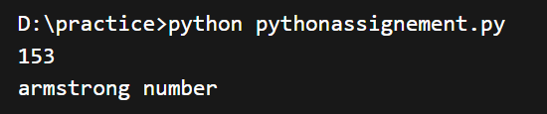
47) Python Program to Find Length of String Without len()
string=input("enter string:")
count=0
for x in string:
count+=1
print("length is:",count) 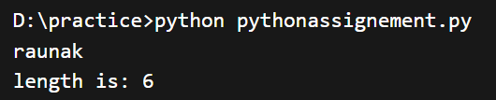
48) Python Program to Find Common Elements in Two Lists
l1=[1,2,3,4]
l2=[3,4,5,6]
for x in l1:
if x in l2:
print("common element:",x)
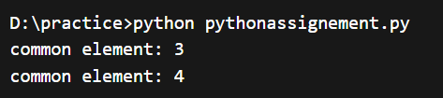
49) Python Program to Convert String to Uppercase
string=input("enter string:")
print("uppercase:",string.upper())
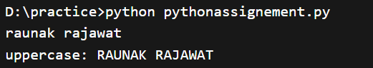
50) Python Program to Find Second Largest Number
l=[10,20,4,45,99]
l.sort()
print("second largest:",l[-2])
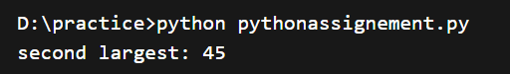
51)Python Program to Find Numbers Divisible by Another Number
my_list=[12,65,54,39,102,339,221]
result=list(filter(lambda x:(x%13==0),my_list))
print("num is divisible by 13 are:",result)
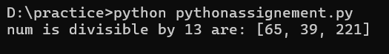
52)python program Slice below tuple to get elements from the 4th to the 7th position
number=(10,20,30,40,50,60,70,80)
s=number[3:7]
print(f"sliced tuple:{s}")
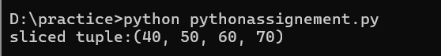
53)Write a code to access and print value 20 from given nested tuple.
tuple1=("yara",[10,20,30],(5,15,25))
print(tuple1[1][1])
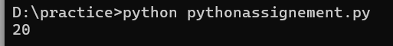
54)Write a code to unpack the following tuple into four variables and display each variable.
tuple1=(10,20,30,40)
a,b,c,d=tuple1
print(a)
print(b)
print(c)
print(d)
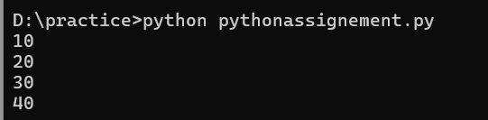
55)Write a program to copy elements 44 and 55 from the following tuple into a new tuple.
tuple1=(11,22,33,44,55,66)
tuple2=tuple1[3:-1]
print(tuple2)
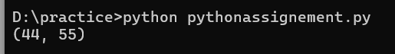
56)Compare two tuples and find out which one is “greater” and why?
t1=(1,2,3)
t2=(1,2,4)
if t1>t2:
print(f"{t1}is greater than {t2}")
elif t1<t2:
print(f"{t1}is less than {t2}")
else:
print(f"{t1} is equal to {t2}")
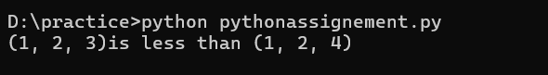
57)Write a code to create a new tuple with only unique elements.
tuple1=(1,2,2,3,4,5,4)
unique_tuple=set(tuple1)
unique_tuple1=tuple(unique_tuple)
print("unique elements:",unique_tuple1)
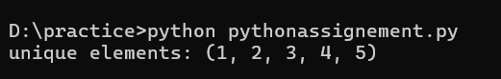
58)Given is a nested tuple. Write a program to modify the first item (22) of a list inside a following tuple to 222
tuple1=(10,[22,33],44,55)
tuple1[1][0]=222
print(tuple1)
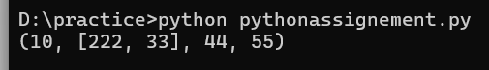
59)Write a code to counts the number of occurrences of item 50 from a tuple
tuple1=(50,10,60,70,50,50)
print(tuple1.count(50))
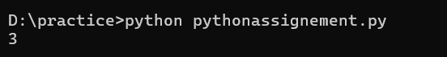60)Replace a stirng with another string
my_name="raunak rajawat"
print(my_name.replace("r","R"))
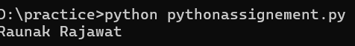
61)Split a string into substrings
my_string="my name is raunakrajawat"
print(my_string.split(" "))
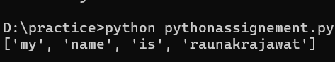
62)WAP to check given two number which is the largest number
Num1=int(input("Enter first number:"))
Num2=int(input("Enter second number:"))
if Num1>Num2:
print("Num1 is biggest number")
else:
print("Num2 is the biggest number")
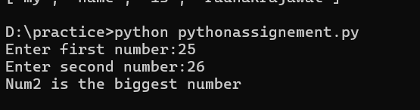
63)Python Program to Display Powers of 2 Using Anonymous Function
result = list(map(lambda x: 2 ** x, range(10)))
print(result)
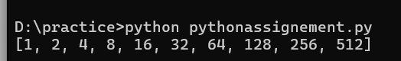
64)Python Program to Convert Decimal to Binary, Octal and Hexadecimal
decimal_num=int(input("Enter the decimal number:"))
print(bin(decimal_num), "in binary.")
print(oct(decimal_num), "in octal.")
print(hex(decimal_num), "in hexadecimal.")
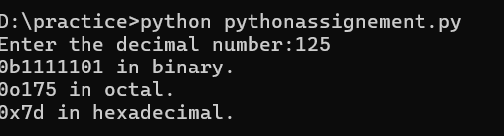
65)Python Program to Find the Sum of Natural Numbers
n = int(input("Enter a number: "))

if n < 0:
print("Please enter a positive number.")
else:
sum_val = (n * (n + 1)) // 2
print(f"The sum of natural numbers up to {n} is {sum_val}")
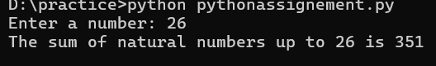
66) Python Program to Check Perfect Number
num=int(input("enter number: "))
sum=0
for i in range(1,num):
if num%i==0:
sum+=i
if sum==num:
print("perfect number")
else:
print("not perfect number")
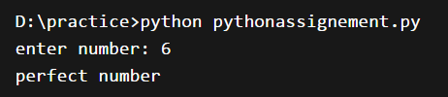
67) Python Program to Count Digits in a Number
num=input("enter number: ")
print("number of digits:",len(num))
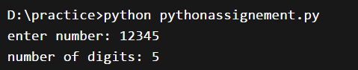
68) Python Program to Find GCD of Two Numbers
a=int(input("enter first number: "))
b=int(input("enter second number: "))
while b:
a,b=b,a%b
print("gcd is:",a)
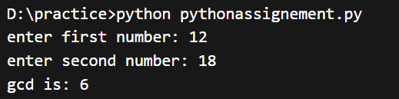
69) Python Program to Find LCM of Two Numbers
a=int(input("enter first number: "))
b=int(input("enter second number: "))
temp=max(a,b)
while True:
if temp%a==0 and temp%b==0:
print("lcm is:",temp)
break
temp+=1
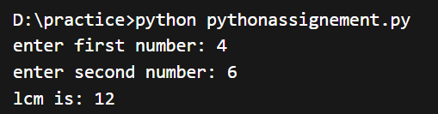
70) Python Program to Reverse a Name
name=input("enter your name: ")
rev=name[::-1]
print("reversed name:",rev)
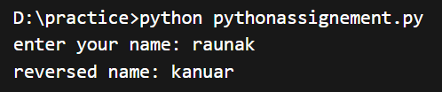
71) Python Program to Check Strong Number
num=int(input("enter number: "))
temp=num
sum=0
fact=[1,1,2,6,24,120,720,5040,40320,362880]
while temp>0:
digit=temp%10
sum+=fact[digit]
temp//=10
if sum==num:
print("strong number")
else:
print("not strong number")
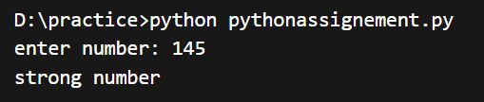
72) Python Program to Find Sum of List Elements
l=[10,20,30,40]
total=0
for x in l:
total+=x
print("sum of list:",total)
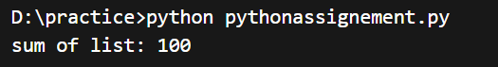
73) Python Program to Check Anagram Strings
s1=input("enter first string: ")
s2=input("enter second string: ")
if sorted(s1)==sorted(s2):
print("anagram")
else:
print("not anagram")
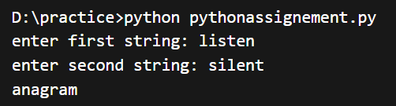
74) Python Program to Find Frequency of Characters in String
string=input("enter string: ")
for ch in string:
print(ch,"=",string.count(ch))
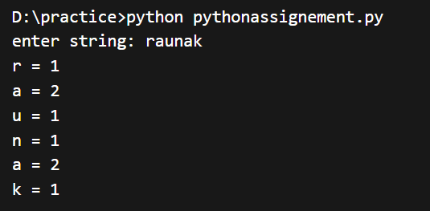
75) Python Program to Print Numbers in Range Divisible by 5
start=int(input("enter start: "))
end=int(input("enter end: "))
for i in range(start,end+1):
if i%5==0:
print(i)
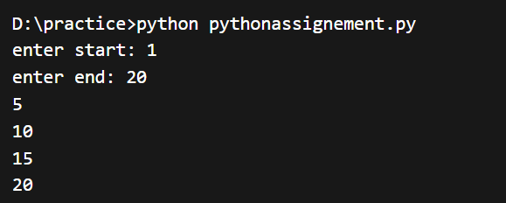
76) Python Program to Check if String is Numeric
s=input("enter string: ")
if s.isdigit():
print("numeric string")
else:
print("not numeric")
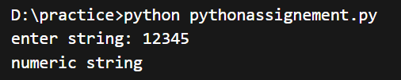
77) Python Program to Find Average of Numbers in List
l=[10,20,30,40]
avg=sum(l)/len(l)
print("average:",avg)
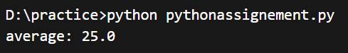
78) Python Program to Print Pattern (Right Triangle)
n=int(input("enter number: "))
for i in range(1,n+1):
print("*"*i)
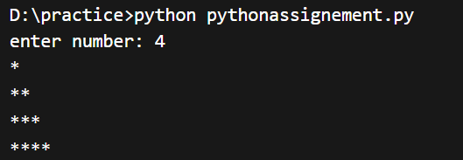
79) Python Program to Remove Spaces from String
s=input("enter string: ")
print("without spaces:",s.replace(" ",""))
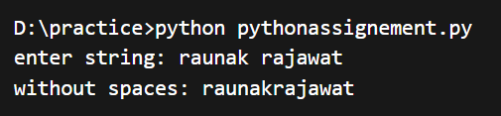
80) Python Program to Find Smallest Element in List (Without min())
l=[34,12,9,56,3]
small=l[0]
for x in l:
if x<small:
small=x
print("smallest element:",small)
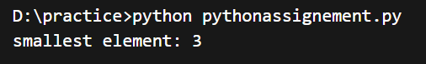
81) Python Program to Convert String to Lowercase
s=input("enter string: ")
print("lowercase:",s.lower())
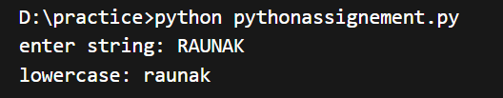
82) Python Program to Find Sum of Even Numbers in List
l=[1,2,3,4,5,6]
sum=0
for x in l:
if x%2==0:
sum+=x
print("sum of even numbers:",sum)
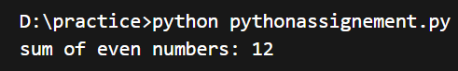

83) Python Program to Check First Letter is Capital
s=input("enter string: ")
if s[0].isupper():
print("first letter is capital")
else:
print("first letter is not capital")
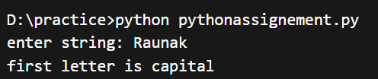
84) Python Program to Count Uppercase Letters
s=input("enter string: ")
count=0
for x in s:
if x.isupper():
count+=1
print("uppercase letters:",count)
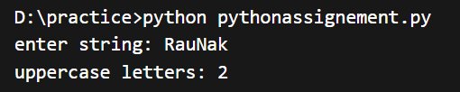
85) Python Program to Print Table of Any Number
n=int(input("enter number: "))
for i in range(1,11):
print(n,"*",i,"=",n*i)
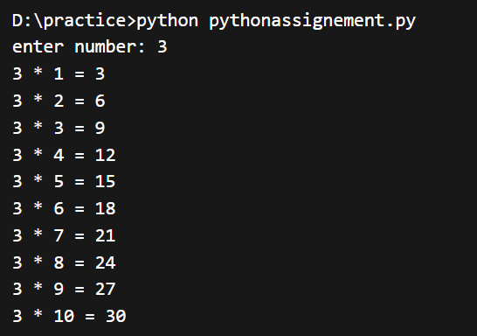
86) Python Program to Check String Ends with Given Character
s=input("enter string: ")
ch=input("enter character: ")
if s.endswith(ch):
print("string ends with",ch)
else:
print("does not end with",ch)
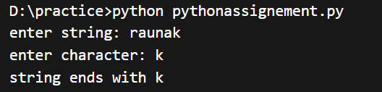
87) Python Program to Find Length of List
l=[10,20,30,40,50]
count=0
for x in l:
count+=1
print("length of list:",count)
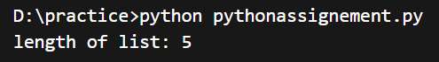
88) Python Program to Check if Number is Multiple of 3 and 7
n=int(input("enter number: "))
if n%3==0 and n%7==0:
print("multiple of both 3 and 7")
else:
print("not multiple of both")
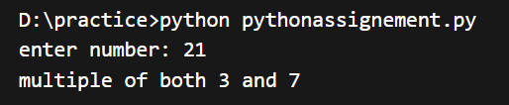
89) Python Program to Reverse Words in Sentence
s=input("enter sentence: ")
words=s.split()
print("reversed words:",words[::-1])
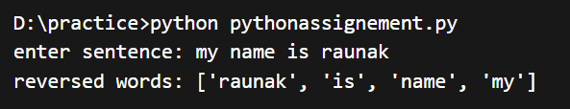
90) Python Program to Find Largest Element Without max()
l=[12,45,7,89,34]
large=l[0]
for x in l:
if x>large:
large=x
print("largest element:",large)
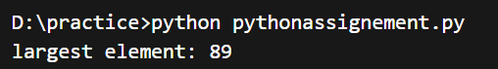
91) Python Program to Check if String is Palindrome (Case Insensitive)
s=input("enter string: ")
if s.lower()==s.lower()[::-1]:
print("palindrome")
else:
print("not palindrome")
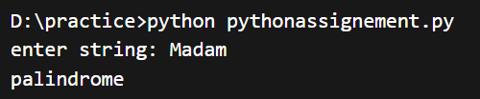
92) Python Program to Count Spaces in a String
s=input("enter string: ")
count=0
for x in s:
if x==" ":
count+=1
print("number of spaces:",count)
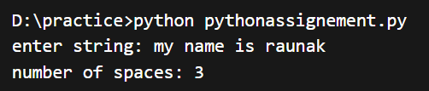

93) Python Program to Print ASCII Values of String
s=input("enter string: ")
for x in s:
print(x,"=",ord(x))
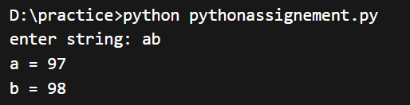
94) Python Program to Find Cube of Number
n=int(input("enter number: "))
print("cube is:",n**3)
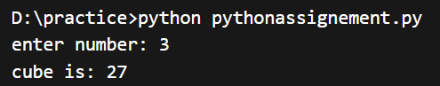
95) Python Program to Check if List Contains Element
l=[10,20,30,40]
n=int(input("enter number: "))
if n in l:
print("element found")
else:
print("element not found")
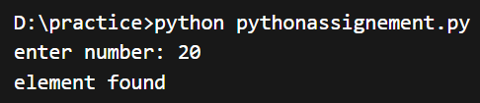
96) Python Program to Find Square of List Elements
l=[1,2,3,4]
for x in l:
print("square of",x,"=",x*x)
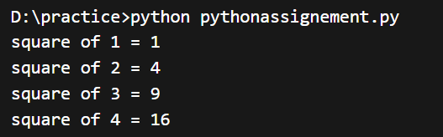
97) Python Program to Count Consonants in String
s=input("enter string: ")
count=0
for x in s:
if x.isalpha() and x.lower() not in "aeiou":
count+=1
print("consonants:",count)
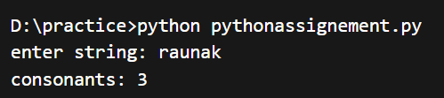
98) Python Program to Print Even Numbers in Range
start=int(input("enter start: "))
end=int(input("enter end: "))
for i in range(start,end+1):
if i%2==0:
print(i)
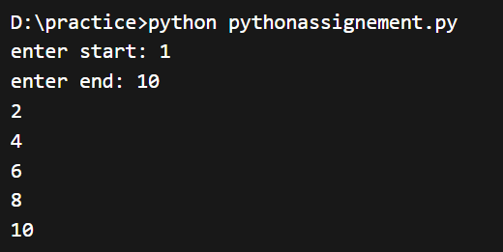
99) Python Program to Find Sum of Odd Numbers in Range
start=int(input("enter start: "))
end=int(input("enter end: "))
sum=0
for i in range(start,end+1):
if i%2!=0:
sum+=i
print("sum of odd numbers:",sum)
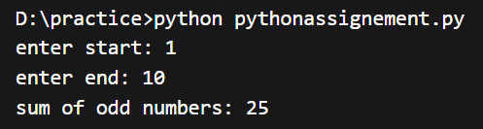
100) Python Program to Display Student Info
name=input("enter name: ")
branch=input("enter branch: ")
print("student name:",name)
print("branch:",branch)
